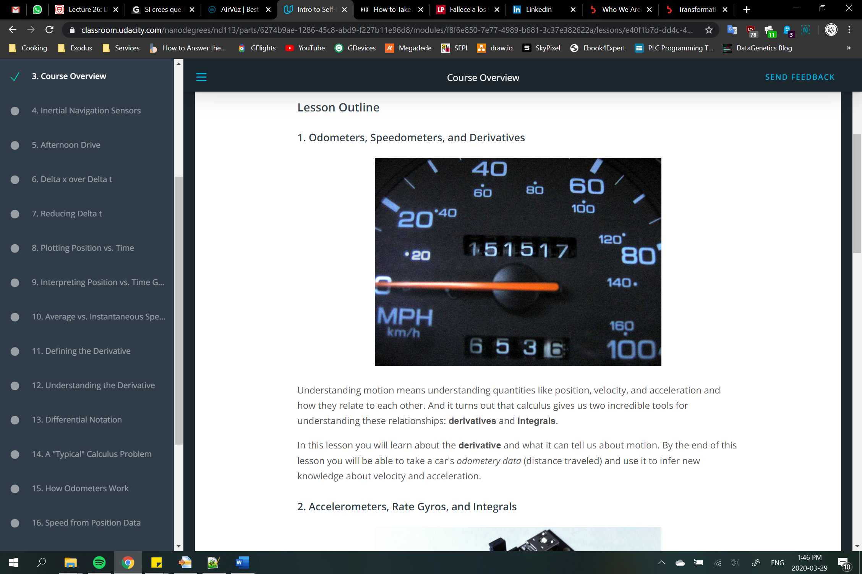

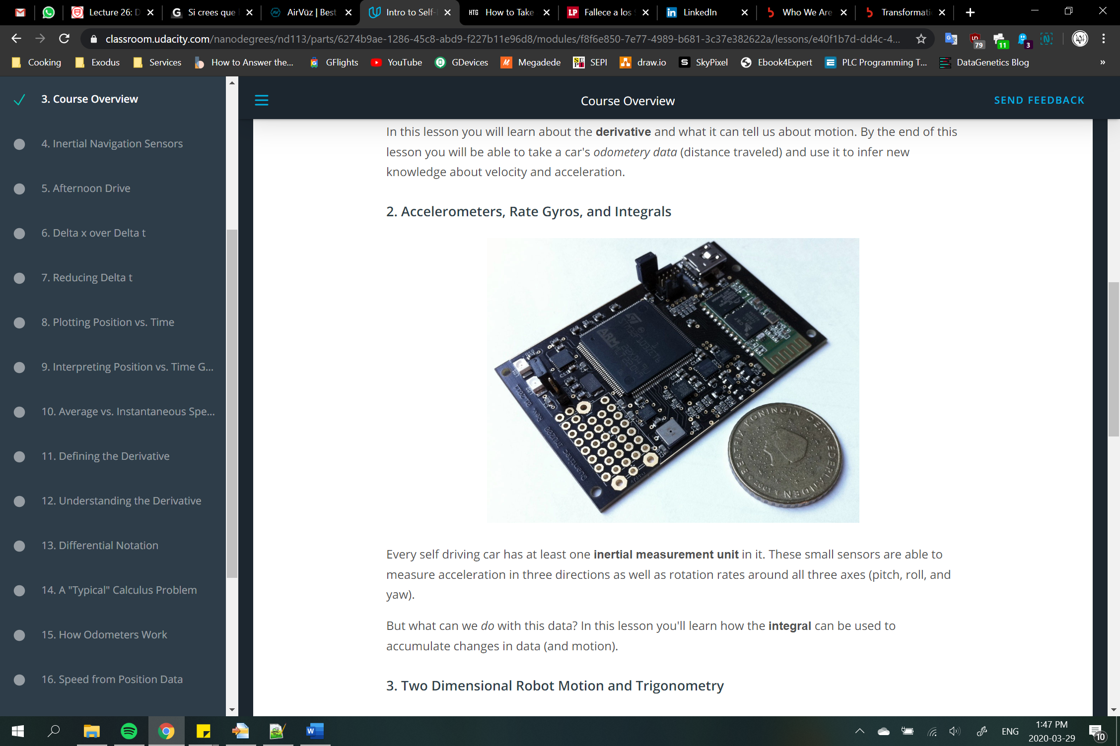

**Navigation Sensors**

We will be discussing the following sensors in this course:

* **Odometers** - An odometer measures how far a vehicle has traveled by counting wheel rotations. These are useful for measuring distance traveled (or *displacement*), but they are susceptible to **bias** (often caused by changing tire diameter). A "trip odometer" is an odometer that can be manually reset by a vehicle's operator.
* **Inertial Measurement Unit** - An Inertial Measurement Unit (or **IMU**) is used to measure a vehicle's heading, rotation rate, and linear acceleration using magnetometers, rate gyros, and accelerometers. We will discuss these sensors more in the next lesson.

It can be dangerous to rely on accelerometer data for localization since errors have a tendency to accumulate. This is a weakness of accelerometers.

Fortunately, it takes some time for these errors to accumulate. So when they're used over short time intervals accelerometers can be really helpful.